**#Python program to different types of inheritance**

**Multilevel**

class A:

def first_method(self):

print("Method of class A...")

class B(A):

def second_method(self):

print("Method of class B....")

class C(B):

def third_method(self):

print("Method of class C...")

if __name__=="__main__":

ob=C()

ob.first_method()

ob.second_method()

ob.third_method()

#C().third_method()

**OUTPUT**

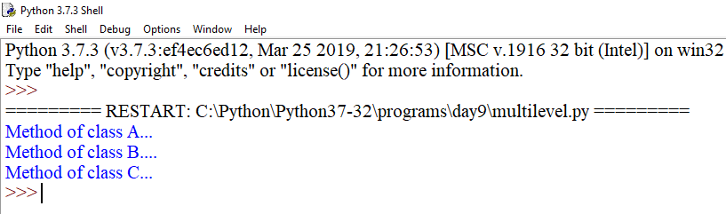

**Multiple**

class A:

def first_method(self):

print("Method of class A...")

class B:

def second_method(self):

print("Method of class B....")

class C(A,B):

def third_method(self):

print("Method of class C...")

if __name__=="__main__":

ob=C()

ob.first_method()

ob.second_method()

ob.third_method()

#C().third_method()

**OUTPUT**

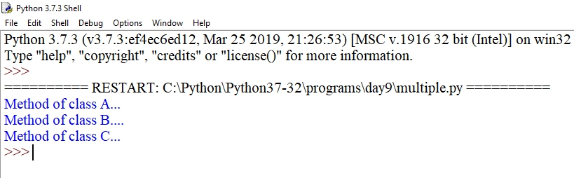

class A:

def first_method(self):

print("Method of class A...")

class B:

def first_method(self):

print("Method of class B....")

class C(A,B):

def third_method(self):

print("Method of class C...")

if __name__=="__main__":

ob=C()

ob.first_method()

ob.third_method()

#C().third_method()

**OUTPUT**

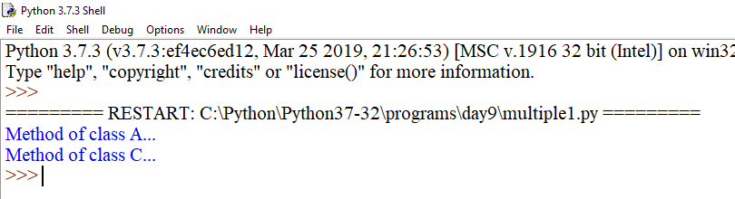

**Override**

class Wolf:

def __init__(self,name,color):

self.name=name

self.color=color

def bark(self):

print("Grr.........")

class Dog(Wolf):

def bark(self):

print("Woof")

pet1=Dog("Tommy","Brown")

pet1.bark()

pet2=Wolf("Jimmy","Grey")

pet2.bark()

Dog("abc","xyz").bark()

**OUTPUT**

